There was lots of hand-wringing after the election about how the media had messed up. Were we too quick to believe the polls? Did we have any idea what real Americans actually thought? Did we give Donald Trump too much attention—or not enough? Now that journalists have spent a few months covering President Trump, we asked a range of media critics, political operatives, historians and more: What does the press still get wrong about Trump, and what do we just not get at all?
1. We forget what has always driven Trump.
Gwenda Blair, author of The Trumps: Three Generations of Builders and a President
Too often, the press forgets the very lessons Trump himself has taught us about how he operates and why it often works. For example, journalists often imply that Trump’s reliance on cable news is a liability because it leaves him ill-informed. And so it does—but it also leaves him highly attuned to that medium and able to respond to what he sees there with immediate, pitch-perfect tweets or other comments that come across as direct, authentic and trustworthy.
Another example: the power of repetition. Frequently, reporters assume that because they have already responded to a Trump assertion, the issue is settled. But then he repeats the same misinformation, as he did in defending the size of his inauguration crowds. In part, this is because he’s incapable of acknowledging loss or error. More important, it’s because one of his highest priorities is the construction of an alternate narrative and the delegitimization of the mainstream media, traditional authorities, and the primacy of facts.
Likewise, the press seems to have forgotten the power of distraction. Coverage of the Trump-ordered missile attack in Syria made little reference to how conveniently it deflected attention from Russia-gate, Trump’s conflicts of interest, his draconian budget cuts, etc. The media also understate Trump’s reliance on bullying, which works surprisingly well for him. With the recent exception of the House Freedom Caucus’ refusal to knuckle under and vote for the GOP’s health care act, most people (e.g., the other Republican presidential candidates and many TV commentators) back down.
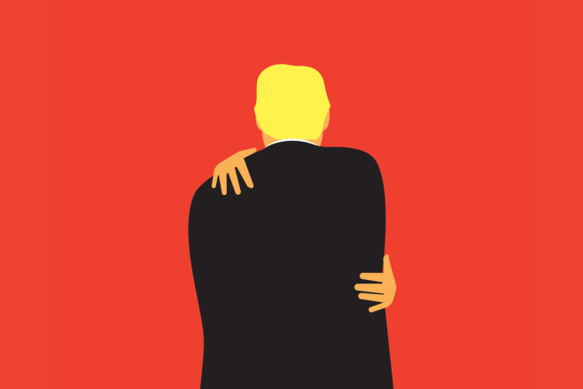
Illustration by Ben Wiseman
Trump has also mastered the power of grievance and continues to use it. When an issue gets too sticky, he reverts to self-pity—fashioning himself as the victim of Barack Obama’s supposed wiretapping, for instance. The media might call such behavior weak or petty, but it also re-cements Trump’s bond with his followers as fellow victims of the Washington elite.
Finally, the press tends to forget how much Trump needs to keep experiencing the act of winning—and how much this drives his behavior. The likeliest reason for his charge that Obama wiretapped him is that Trump wants to feel as if he’s continuing to beat the biggest competitor he can find. And what bigger target than Obama?
2. Trump. Won’t. Change.
Kurt Bardella, president and CEO of Endeavor Strategies
Anyone who thought Trump would pivot and become a more conventional political figure after he took the oath of office was completely misreading him and his psyche. Trump is, and always will be, a promoter. Facts and specifics are secondary to tone, style and strength. In the immediate aftermath of his first address to Congress, the political and media community was quick to point to that speech as a turning point. For one hour, Trump acted presidential—“acted” being the key word. Days later, he took to Twitter and remarkably and falsely accused his predecessor of wiretapping his offices. So much for turning over a new leaf. And that’s the point: No matter what happens, how far his numbers plummet or how often his statements are fact-checked, Trump is not going to change, and his audience doesn’t want him to. For almost a decade now, the American people have been bombarded with messaging from campaigns that highlight how Washington is broken, how the status quo is failing them and how change is needed. Hundreds of millions of dollars in advertising across all TV, print, radio and digital have been spent hammering this fundamental message into the minds of the American people. Trump is not part of the status quo that Americans have now been conditioned to oppose—and he’s not going to change to accommodate to Washington.
3. We still trust the polls too much.
Helmut Norpoth, political scientist at Stony Brook University
During the campaign, almost nobody in the media gave Trump a chance to win the election. That gloomy prospect largely derived from his poor standing in the polls, both nationally and in the major battleground states, with almost no poll showing Trump leading in the three states that clinched his victory in the Electoral College—Michigan, Pennsylvania and Wisconsin. This failure, one might think, would give the media some pause in seizing on polls that now show Trump with low approval, the worst of any president at this stage. But no, polls nowadays feed news coverage that gives Trump little chance to make it through his first term and assumes there’s no way for him to avoid a midterm disaster. Granted, presidential approval is not the same as a vote choice, but it is a proven predictor of the vote in midterm and presidential elections. It is odd to see journalists retain their faith in a discredited source instead of questioning its reliability. Shouldn’t they instead launch an inquiry into the 2016 polling fiasco?

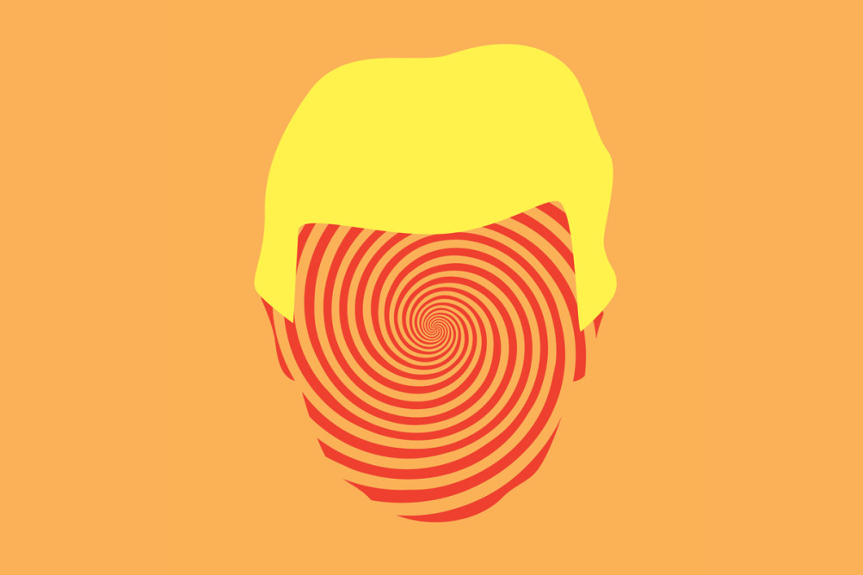
Illustration by Ben Wiseman
4. ‘Trump is crazy’ has become a cliché.
John McWhorter, associate professor of linguistics at Columbia University and author of Words on the Move: Why English Won’t—and Can’t—Sit Still (Like, Literally)
The cherished idea that Trump is mentally unstable, endlessly massaged by media writers, is weak. Too many of us have known people much like him in his boyish, defensive, unfocused and breezily incurious essence; it is almost weird that we are pretending that it is a sign of pathology that someone has a hard time admitting he’s wrong. Trump is simply a profoundly mediocre person tragically unfit for the presidency. What’s “crazy” is that he wound up there.
Social media’s eclipse of the smoke-filled room accounts for that much more gracefully than an alarum painting Trump as fit for psychoanalysis and medication. Is this idea of Trump as madman possibly a variation on the too-typical disparagement of the modestly educated whites “out there” who voted for Trump? Now that the general call in the media is to hold off on tarring them as racist troglodytes and sexists, it seems that a new way of punishing them is to say that they were so dumb they elected an obvious lunatic to the presidency because he said he would get their jobs back. But what if he is less loony than just a jerk? Plenty of presidents have been jerks, and possibly most of them.
Neither the media nor the “out there” people deserve anything called blame for Trump’s election. Social history is not only nasty but complex. Pointing fingers, however, isn’t.
5. We’re not only stuck in bubbles—social media is making them worse.
Emily Parker, former chief strategy officer at Parlio and author of Now I Know Who My Comrades Are: Voices from the Internet Underground
On March 15, a Guardian correspondent tweeted a photo of a Trump voter at a rally for the president in Nashville. The man was holding a sign that read, “I’ve made a huge mistake.” This was a perfect distillation, it seemed, of the regret that onetime Trump supporters were surely feeling now that he was actually in office. Sure enough, the tweet was retweeted more than 40,000 times.
Viral images create their own kind of truth. One man’s sign can give the impression that Trump voters are changing their minds more than they are, or that the rally was a failure. This is not the Guardian correspondent’s fault. There’s no reason to believe that the photo was fake news, or that the journalist was trying to mislead. He was reporting “from the ground,” and not from the coastal media bubbles. That same day, he also tweeted a photo of White House press secretary Sean Spicer surrounded by fans (though it very got few retweets).
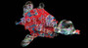
FOURTH ESTATE

The Media Bubble Is Real—And Worse Than You Think
By JACK SHAFER and TUCKER DOHERTY
The “huge mistake” tweet is just one example of a more widespread phenomenon. Images like this can buoy those in the Trump opposition—who, after all, may be more likely to read reporters’ tweets. But such images also risk lulling people into thinking that Trump is less popular than he is. Too often, we cherry-pick examples that fit our worldview, and social media blows them out of proportion. Many journalists vastly underestimated Trump’s popularity before the election; the media need to avoid making the same mistake now that he is president.
6. We’re still ignoring the people who elected Trump.
Matthew Continetti, editor in chief of the Washington Free Beacon
There was a brief moment after the election when the press said it would devote more coverage not to Trump but to the people who had voted him into office. What had driven 46 percent of the country to vote for an outsider billionaire with no government experience, despite serious reservations about his temperament and character, was a question that deserved an answer. Was it really the case that rising inequality and political polarization had separated the makers of news and opinion at our most eminent outlets from about half of the public they sought to inform?
I think it was. Washington and New York have done so well in the past 20 years that residents of those cities and their suburbs—and I am one—could not see beyond the geographic and economic and social boundaries of our lives. We were largely immune from the collective shocks of the early 21st century: the border shock of rising illegal immigration, the trade shock of Chinese imports, the economic shock of the financial crisis, and the confidence shock of disappointing outcomes in Iraq and Afghanistan. We are continually tempted to devote our attention and resources to parochial concerns, to the Beltway questions of who is up and who is down, which party is winning and which is losing, what controversy the president finds himself mired in today. But this is to miss the forest for the tweets.
If there is one thing the press still gets wrong about Trump, it is treating him in isolation from the very real and worrisome social conditions that brought him to power.

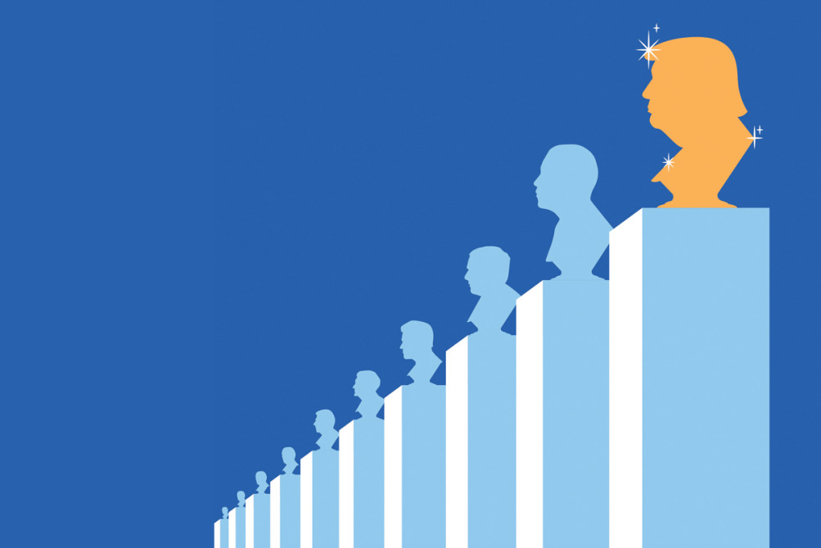
Illustration by Ben Wiseman
7. We’re falling for the ‘Trump exceptionalism’ trap.
Nicole Hemmer, assistant professor of presidential studies at the Miller Center at the University of Virginia and author of Messengers of the Right: Conservative Media and the Transformation of American Politics
Many journalists covering the White House have lapsed into a practice of “Trump exceptionalism,” a tendency to assume each move the administration makes is new and nefarious. This assumption comes from a well-meaning place—a worry that they will be complicit in normalizing dangerous behavior in an American leader. But there are real risks, too.
First, it leads to quick-trigger panic over events that are normal. Take the reaction to the administration’s dismissal of 46 U.S. attorneys. Journalists framed it as a purge, and the panic escalated when one of those attorneys, Preet Bharara, refused to resign and was subsequently fired. But the dismissal of U.S. attorneys has been standard practice since the 1990s. The novel behavior here was Bharara’s. There’s a cost to getting this wrong: Cry wolf too many times, and readers are less likely to listen when the real dangers appear.
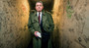
THE POLITICO MAG PROFILE

Dan Rather’s Second Coming
By MICHAEL KRUSE
But perhaps the more important consequence of Trump exceptionalism is that it encourages journalists to overlook continuities. Trump is an abnormal president, unprecedented in many ways. But he is not sui generis. His anti-Muslim policies, hard-line anti-immigration stance, even his economic populism and free-trade skepticism all have long histories—even within mainstream conservatism. His nomination of Neil Gorsuch to the Supreme Court was as straightforwardly Republican as it gets.
Avoiding “Trump exceptionalism” simply requires asking how the events of each very eventful day fit into American political history. Often they won’t fit in at all. But that should be an open question, not an operating assumption.

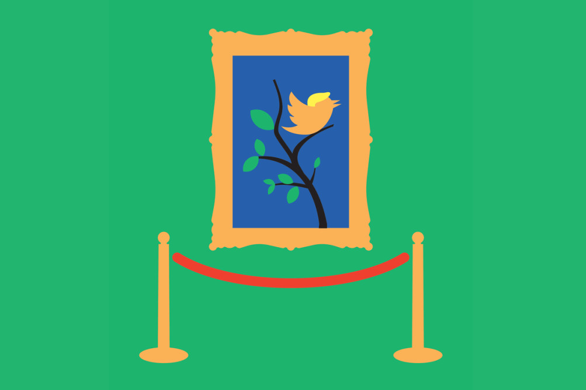
Illustration by Ben Wiseman
8. We should take Trump’s tweets more seriously.
Leah Wright Rigueur, assistant professor of public policy at the Harvard Kennedy School of Government and author of The Loneliness of the Black Republican: Pragmatic Politics and the Pursuit of Power
It’s clear that Twitter helped “make” Trump a politician, and as president, he continues to use his account in radical ways. But three months into his presidency, the media still don’t seem to know how to handle Trump’s continued social media outbursts.
Since the election, we’ve heard arguments insisting that his tweets are “un-presidential”; that they’re only a “distraction” from more pressing or serious issues; that the media should stop hyperfocusing on them; even that someone should take away Trump’s Twitter account. If the 2016 campaign taught us anything, however, it’s that so long as Trump sees social media as an invaluable platform for delivering his message directly to the American public, he will continue to tweet and post.
But Trump’s tweets are legitimately important and necessary to watch. The political landscape isn’t theoretical anymore—this is real life with real, monumental consequences. As historical evidence, Trump’s social media posts provide the public and the press with an immediate way to track his administration’s proposed bills, orders and directives—and hold the president accountable for those policies. We’re already beginning to see how Trump’s own tweets—about the travel ban and his wiretapping accusations—can be used to analyze and challenge his agenda. The media and the public must treat Trump’s social media usage—before and after the 2016 campaign—as something serious and worthy of investigation, not a spectacle for ogling or entertainment, or a nuisance that simply needs to go away.
9. The media’s priorities are all wrong.
Zeynep Tufekci, associate professor at the University of North Carolina School of Information and Library Science and author of the forthcoming Twitter and Tear Gas: The Power and Fragility of Networked Protest
The press faced a range of structural weaknesses that led to its failures before the 2016 election. These weaknesses are persisting—albeit with slightly better optics because journalists face a more adversarial administration, which creates a misleading illusion of improvement.
The problem is both structural and ethical. For starters, media are clustered [cloistered?], and prone to herding. Not only did this cause them to underestimate Trump’s election chances, but they continue to miss the dynamics of polarization in this country, and what that means for politics. Pundits and many journalists also remain attracted to horse-race stories that resemble fiction (stumble in the second act! comeback in the third act!), which causes them to miss real dynamics because they are too busy fitting their reporting into interesting narrative structures. This also does a disservice to journalists’ remaining essential role: telling the rest of us about important questions of policy and substance that we cannot easily access, investigate or absorb on our own.
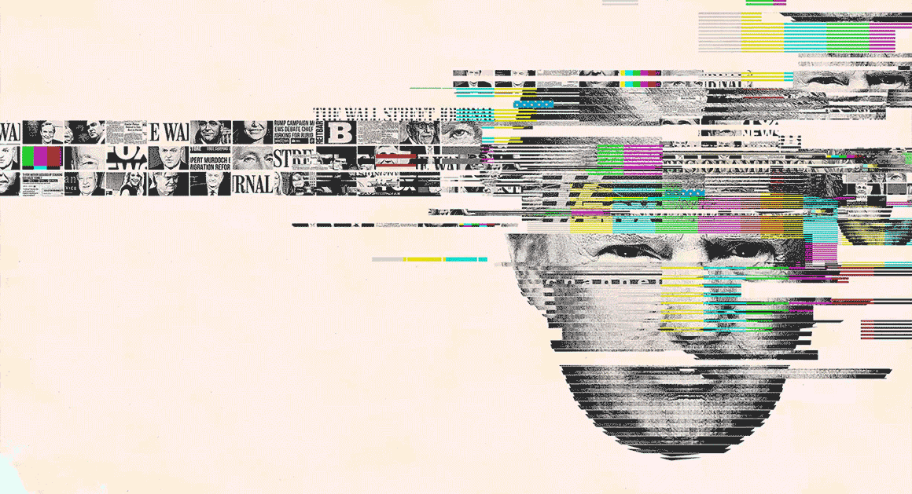
FOURTH ESTATE

How Trump Blew Up the Conservative Media
By ELIANA JOHNSON
What’s more, many journalists still practice “access journalism”—which is futile. Thanks to social media and partisan cable channels, politicians now easily have their own access to audiences. The old style of access journalism often amounts to little more than reporters being subjected to spin by the insiders. But even after the election, process and inside-the-White House stories continue to interest journalists (and a large section of the so-called chattering classes) disproportionate to those stories’ political or policy importance.
Structurally, the digitally led decoupling of individual stories from newspapers has meant that solid investigative work is no longer financed by ads and gossipy punditry. But gossipy punditry and contrarianism can still bring clicks—the way sugary soda sells. So they persist, and the whole news ecology is further degraded, despite the fact that there are many really good investigative journalists out there. Finally, media are still getting played by outlets like WikiLeaks that simply prey on journalists’ weaknesses—
- being prone to gossip;
- not understanding technical stuff;
- prizing “copy” at regular intervals
so they can’t take their eyes off drip-drip-drip leaks to figure out what’s going on.
One bright spot in all this is that subscriptions are rising: That may allow media outlets some independence, but improvements will likely come only if subscribers match their money with a demand that the media reckon with their profound and historic failure in 2016.


Illustration by Ben Wiseman
10. We haven’t nailed the biggest story. [We think Russian interference in the election is the Biggest Story.]
Jill Abramson, former executive editor of the New York Times
It’s been thrilling to see so much first-rate investigative journalism about the Trump administration. But we still haven’t gotten to the bottom of Russian interference in the election, perhaps the most consequential political story of 2016. Coverage has been intense at times, especially when it comes to Trump officials lying about their Russian contacts. But then the coverage wanes or gets caught up in minor scoops, and the public loses the thread. Meanwhile, the Russia side of the story is still shrouded in darkness. That story requires very difficult reporting, which is why it would be productive for quality news organizations like the New York Times, Washington Post, ProPublica, CNN, BuzzFeed News, the Guardian and a few others to form an investigative consortium to dig, discover and confirm reporting that reveals the true extent of foreign meddling. The attempt to disrupt our democratic electoral process deserves a bold force multiplier. [stupid.]
11. The press is still biased against Trump.
Mark Bauerlein, senior editor at First Things and professor of English at Emory University
The media continue to misconstrue Trump’s image and character—including his appeal to many Americans—because they don’t realize how tiresome identity politics and grievances have become. Throughout the campaign, journalists cited Trump’s –isms and –phobias again and again, relentlessly playing his “shocking” words. They ignored the hypersensitivity and indignation of his critics.
- Who were those individuals blocking a highway in Phoenix in order to disrupt a Trump event?
- What kind of people concocted such a monstrous vision of him that they went out and burned cars and smashed storefronts in Washington, D.C., and elsewhere?
- Why do entertainers and commentators believe Trump and his supporters are so appalling that profanity is in order?

Since the inauguration, the irrationality has only gotten worse. But while we have strong analysis and correction by the media of the Trump administration—as we should—the protesters undergo little inquiry. They are simply cast as conscientious objectors to a bad leader. We need the press to do its job and tell us who the organizers are, where the money comes from, and what the rank and file in the crowds want.
12. Trump’s success depends just as much on what happens outside Washington.
Jessica Yellin, senior fellow at the USC Annenberg Center on Communication Leadership & Policy and former chief White House correspondent for CNN
Political reporters are doing a fantastic job covering Washington, D.C., under extremely challenging conditions. But we still need to devote more resources to covering on-the-ground reality in communities across the country. Consider these recent stories:
Jobs: Rexnord industrial bearings, less than 2 miles from the Carrier plant in Indianapolis, is shipping some 300 jobs to Mexico, according to the Indianapolis Star and the Associated Press. After all the television coverage devoted to the president’s negotiations to keep some Carrier jobs in the United States, where are the cameras [reporters] now?
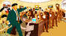
1600 PENN

The Jungle-Warfare Theory of Trump
By MARK FELDSTEIN
Immigration: Nebraska meatpackers rely heavily on refugees and immigrants to staff their food processing plants. Now, the Omaha World-Herald reports that the industry, fearing labor shortages caused by the crackdown on foreign workers, is considering moving toward machine labor and/or cutting back on production.
Travel: In March, USC held a three-day African trade summit with zero Africans, VOA News and the Guardian reported. One hundred percent of the attendees from Africa—at least 60 people—were denied visas, blocked from attending an event meant to give American businesses more investment opportunities overseas.
These aren’t just human-interest stories. They’re about the real-world impact of our policies and politics. When they do get national pickup, it’s fleeting compared with coverage of, say, the search for leakers in the White House. Trump’s election was an outside-the-Beltway phenomenon. It would be a mistake to cover his presidency as a largely inside-the-Beltway reality.

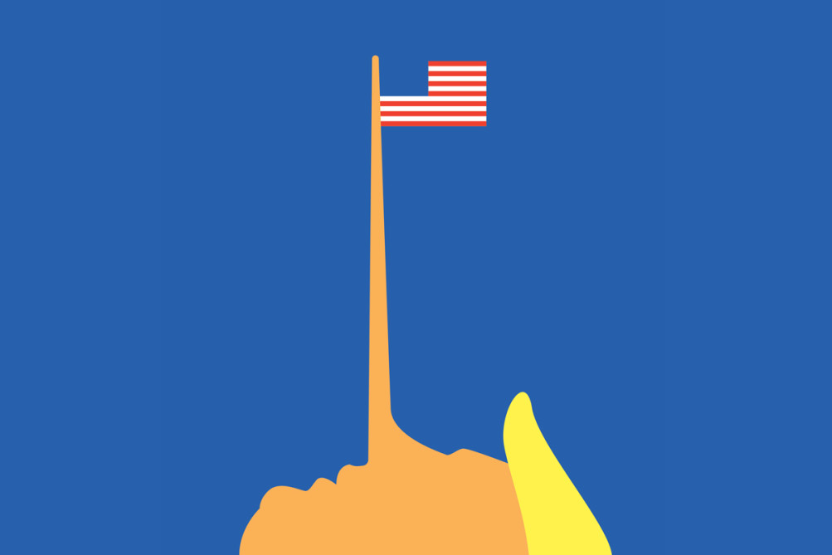
Illustration by Ben Wiseman
13. Most people don’t care about Trump’s lies.
Terry Sullivan, partner at Firehouse Strategies and campaign manager for Marco Rubio in 2016
Members of the media, in their efforts to cover Trump, are misreading the interests of the American people, who care far more about politicians getting things done than they do about honesty or following protocol. After decades of political gridlock and finger-pointing, [half of] Americans don’t care how it happens—they just want government to govern. Sadly, the American electorate as a whole assumes all politicians lie in some form. Thus, Trump’s supporters see the media’s hyperventilating about his falsehoods as nothing more than proof of journalistic bias—the press didn’t appear to call out Barack Obama’s lies in the same way. Everyone knows a good salesman is lying when he says he can offer a really great deal, but only for you and only today—but the tactic still works. People are willing to believe [accept] the unbelievable in order to get [a fraction of] what they want. And it only helps the salesman’s case to have a foil like the press to berate. The danger for the salesman is when he can’t deliver on the final deal. If the media want to cover what Americans care about, they’ll focus more on whether Trump, too, can deliver.

